

FRS Plug-In
Installation and
Administration Guide

EN-Node

Version: 1.1

12/6/2010



11 Princess Road, Unit A
Lawrenceville, New Jersey 08648
www.enfotech.com

Restriction on Use and Disclosure of Document Information

This document includes data that should not be disclosed outside the business entity for which it was intended, indicated as the recipient on this title page. The entire document is copyrighted by enfoTech and is protected under the US copyright law and international treaties. No part of this document may be reproduced or transmitted in any form or by any means, electronic or mechanical, for any purpose, without express written permission from enfoTech & Consulting Inc.

Copyright © 2001 – 2009 by enfoTech & Consulting Inc. All Rights Reserved.

Revision History
Version | Date | Created By | Reviewed By | Description
1.0 | 5/12/2009 | Doug Timms |  | Initial version
1.1 | 12/6/2010 | Doug Timms |  | Fix errors in parameter names and solicit

Tables of Contents

1 Document Purpose 4
2 Plug-In Overview 4
3 Installing the Plug-In 5
3.1 Prerequisites 5
3.2 Installation Package Contents 5
3.3 Pre-Installation Preparation 5
3.4 Installation Instructions 5
4 How to Use / Test the Plug-In 7
4.1 Query FRS Data (GetFacilityByChangeDate) 7
5 Appendix A: GetFacilityByChangeDate Plug-In Technical Reference 10
5.1 Plug-In Purpose 10
5.2 Plug-In Overview 10

Document Purpose
This purpose of this document is to provide guidance on the setup, use, and maintenance of the EN-Node FRS Plug-in.
Note: This is for the old FRS v1 and not for the newer FRSv3 service.

Plug-In Overview
This section described how the FRS Plug-In works.

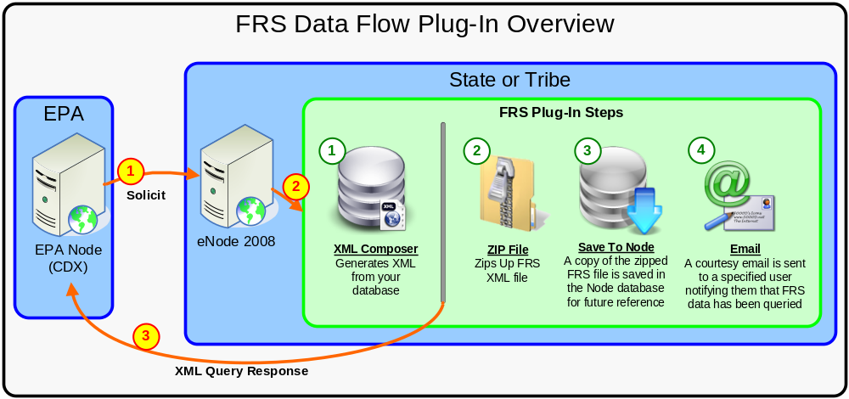
Figure 1: FRS GetFacilityByChangeDate Plug-In Overview

 EPA calls a Solicit against the target node and supplies the following information:
- Request Name: GetFacilityByChangeDate
- Parameter 1: State Code
- Parameter 2: ChangeDate in YYYY-MM-DD format

 The Node2008 invokes the FRS Plug-In. By default, this Plug-In includes the following steps:
  - XML Composer: Uses the eNode2008 XML Generation engine to generate an XML file in FRS format from your source database. When this step is completed, the XML file is immediately returned to the requestor. The Plug-In will also continue executing the following steps.
  - ZIP File: The FRS XML file that was previously generated is compressed into a ZIP file.
  - Save To Node: The Zipped FRS XML file is stored in the Node database for future reference. This file is stored along with the transaction ID and generation date. This allows Node and FRS domain administrators at the State/tribe to review any files that have been sent to EPA for troubleshooting and/or recordkeeping purposes.
  - Web Service: If a ReturnURL is supplied, a submission will be made to the URL provided.

 The FRS XML file is returned to the requestor after the first step in the Plug-In is completed.

Installing the Plug-In

This section is intended for Node Administrators for the one time initial Plug-In installation and configuration. For staff who wish to use the FRS Plug-In, please skip to section Error: Reference source not found.

Prerequisites
- EN-Node has been installed
- A FRS datasource exists in SQL Server or Oracle format

Installation Package Contents
This section identifies the files that are provided as part of the FRS Plug-In Installation Package. The FRS Plug-In Installation Package includes the following:
- FRSToXMLMapper.xml: Provides the logic to map your source database to the FRS XML format
- FRSToXMLTemplate.xml: Provides the destination format for FRS XML files
- FRS_Query_GetFacilityByChangeDate_Wizard.xml: Provides the step-by-step logic in XML format for the FRS Data Flow Plug-In
- FRS_Solicit_GetFacilityByChangeDate_Wizard.xml: Provides the step-by-step logic in XML format for the FRS Data Flow Plug-In

Pre-Installation Preparation
This section identifies steps that should be performed prior to installation.
- Update FRSToXMLMapper.xml with the correct logic to retrieve data from your FRS data source. Because most states/tribes have their own unique databases, this file will need to be updated to correctly retrieve data. In most cases, the only portions of this file that need to be updated are the SQL statements.
- Update FRSPlugInWizard.xml with your state or tribe specific information:
  - Correct connection string to point to your FRS data source
  - Correct email address for receiving courtesy copy emails

Installation Instructions
To configure the FRS Node Plug-In please follow these steps:

- Log in to the Node Administration application as Node Admin

- Create FRS Domain:
  - Click “New Domain” button that is in the Node Domains webpart
  - Enter in Domain name = FRS; Status = Running
  - Allowed Web Services = Query
  - Check off which Node Admin Console users should be domain administrators
  - Click “Save” button to confirm

- Create FRS Query Operation:
  - Return to the Node Dashboard screen
  - Click the “Go to Operations” link for the FRS Domain
  - Click “Create New Operation” button
  - Set Operation Name = GetFacilityByChangeDate; Status = Running
  - Select Operation Type = “Web Service”
  - Click the “Using Data Flow Wizard” checkbox.
  - Click Next
  - Select “Query” from the drop-down
  - Click Add Query Parameters 2 times with these values:
    - StateUSPS
    - ChangeDate-YYYY-MM-DD
  - Click “Go to Data Flow Wizard”
  - Once in the Data Flow Wizard, click the Import button and when prompted, upload the FRSPlugInWizard.xml file.
  - Click on the File Management button at the top of the screen
    - Upload the FRSToXMLMapper.xml file
    - Upload the FRSToXMLTemplate.xml file
  - Click Save.

- Create FRS Solicit Operation:
  - Return to the Node Dashboard screen
  - Click the “Go to Operations” link for the FRS Domain
  - Click “Create New Operation” button
  - Set Operation Name = GetFacilityByChangeDate; Status = Running
  - Select Operation Type = “Web Service”
  - Click the “Using Data Flow Wizard” checkbox.
  - Click Next
  - Select “Solicit” from the drop-down
  - Click Add Solicit Parameters 2 times with these values:
    - StateUSPS
    - ChangeDate-YYYY-MM-DD
  - Click “Go to Data Flow Wizard”
  - Once in the Data Flow Wizard, click the Import button and when prompted, upload the FRSPlugInWizard.xml file.
  - Click Save.

- Setup Plug-In Administrators:
For any person that wishes to access the FRS portions of the Node Administration Utility (to review FRS submissions, etc), you will need to grant them rights to be a FRS Data Flow Administrator. To set this up, follow these steps:
  - Create a new Node Admin Console User
  - Click on the “Domain Management” link
  - Click the name link for the FRS Domain
  - Click the “Assigned” checkbox next to the user that wish to be FRS Admins
  - Click “Save”

How to Use / Test the Plug-In

Query FRS Data (GetFacilityByChangeDate)

After the FRS Plug-In is installed, please follow these steps to test the flow:

Step 1: Authenticate to your node
First authenticate to your node using a Node Client tool:
- Node Address: Provide your Node endpoint
- User Name: Enter your NAAS username
- Password: Enter your NAAS password
- Then click the Authenticate button
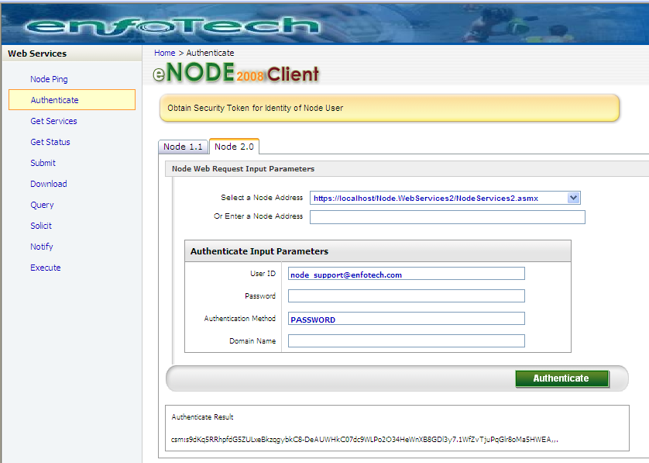

The Result should show a security token similar to the one above.

Step 2: Call FRS GetFacilityByChangeDate Query
Click on the Query link on the left menu to Query data from your Node. Fill in the following information:
- Security Token: should be automatically populated from the step above
- Request Name: GetFacilityByChangeDate
- Parameters:
  - ChangeDate: in format YYYYMMDD
  - OriginatingPartnerName: usually a 2 character state code
  - InformationSystemAcronymName

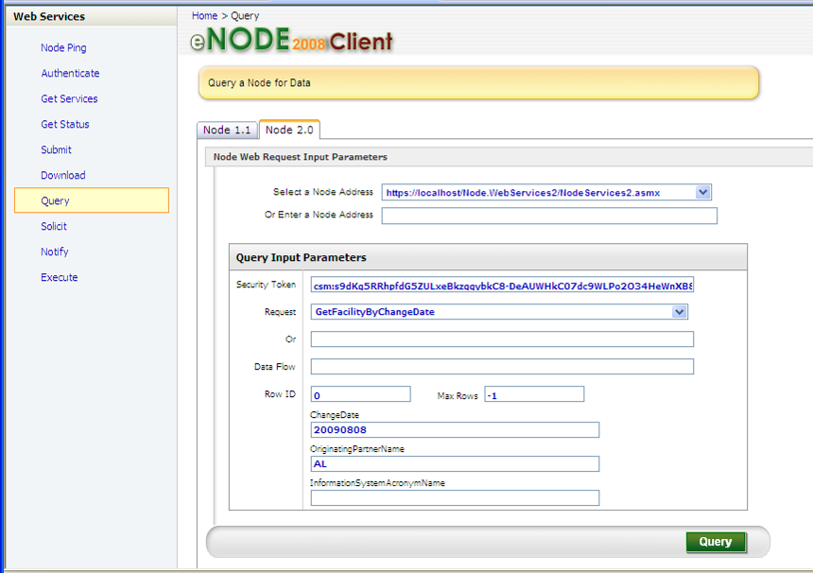

You should be returned with the XML results as shown here:

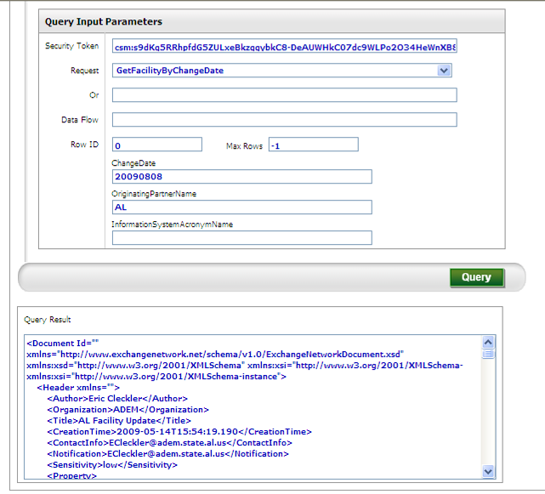

Appendix A: GetFacilityByChangeDate Plug-In Technical Reference

Plug-In Purpose
The GetFacilityByChangeDate operation is a Query service registered under the FRS domain. This appendix provides technical details on this plug-in.

Plug-In Overview
The GetFacilityByChangeDate operation consists of 4 steps:

Step 1: ComposerFRS: Uses the eNode2008 XML Generation engine to generate an XML file in FRS format from your source database. When this step is completed, the XML file is immediately returned to the requestor. The Plug-In will also continue executing the following steps.
- Input: Global::documents
- Output: ComposerFRS::Output

Step 2: Zip FRS File: The FRS XML file that was previously generated is compressed into a ZIP file.
- Input: ComposerFRS::Output
- Output: ZipFRS::Output

Step 3: SaveToNode: The Zipped FRS XML file is stored in the Node database for future reference. This file is stored along with the transaction ID and generation date. This allows Node and FRS domain administrators at the State/tribe to review any files that have been sent to EPA for troubleshooting and/or recordkeeping purposes.
- Input: Unzip::Output
- Output: SaveToNode::output

Step 4: Email: A courtesy email is sent to 1 or more specified users notifying them that the FRS data has been queried. This email identifies the passing parameters supplied by the requestor as well as the transaction ID for the transmission.
- Input: None
- Output: Email::output

